CAPSTONE PROJECT
Executive Summary: NetCore Systems Network & Security Project
Executive Overview
This project presents the design, deployment, and security configuration of a multi-department enterprise network for NetCore Systems Ltd. implemented using Cisco Packet Tracer. The network interconnects with three distinct departments (IT, Sales, and HR) while enforcing access control policy to restrict ICMP traffic without disrupting core network services.
Part A:
1. Project Goal
Design and deploy a three-department enterprise network (IT, Sales, HR) in Cisco Packet Tracer with central services (HTTP/FTP) and targeted security policies using Extended ACLs.
2. Network Topology & Addressing
- Core Hardware: 1× Cisco 2911 Router, 3× Cisco 2960 Switches, 6× PCs, 1× Server.
Department | Subnet / Mask | Default Gateway | Key Host
IT | 192.168.10.0/24 | 192.168.10.1 | IT-SERVER: 192.168.10.2 (HTTP/FTP)
Sales | 192.168.20.0/24 | 192.168.20.1 | Dynamic DHCP Hosts
HR | 192.168.30.0/24 | 192.168.30.1 | Dynamic DHCP Hosts
3. Security Policy (Extended ACL)
- Objective: Block Sales from pinging the IT network while maintaining HTTP and FTP service access.
- ACL Rules (Applied on Sales Gateway Interface):
  - Deny: ICMP traffic from 192.168.20.0/24 to 192.168.10.0/24.
  - Permit: All other IP traffic (permit ip any any).
4. Verification Results
- Sales $→$ IT Ping: Blocked (ICMP restricted by ACL).
- Sales $→$ IT-SERVER (HTTP/FTP): Allowed (Web portal and file transfer accessible).
- HR $→$ IT Network: Allowed (Full connectivity).

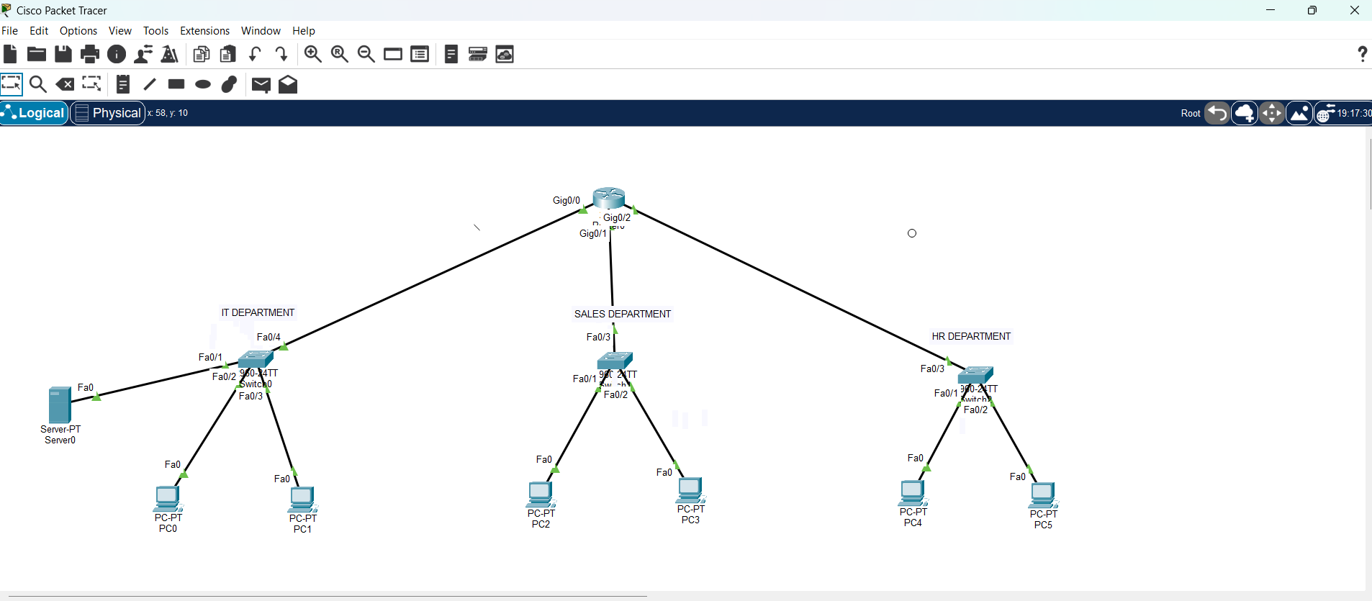

Part B:
The IP configuration parameters for Sales PC2 are illustrated in the screenshot belo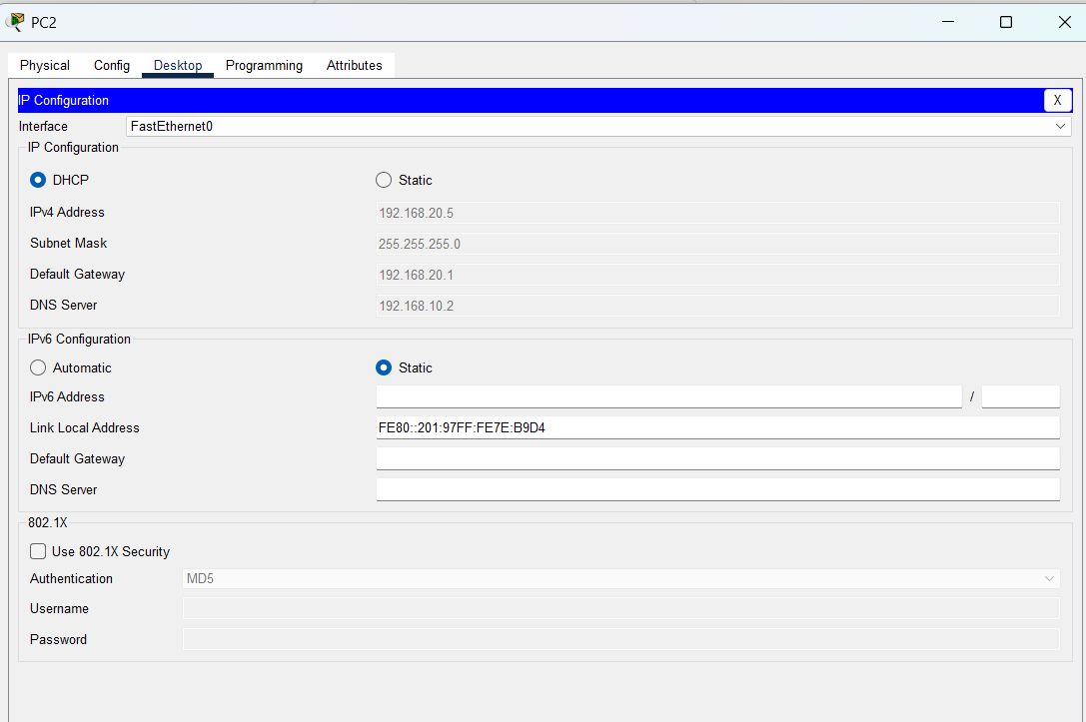

Part C:
Verification: Successful Ping Between HR PC and IT Network
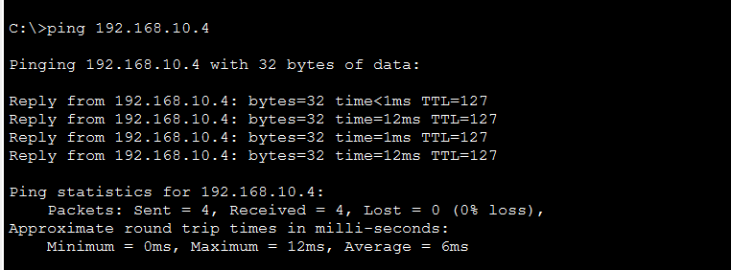

Part D:
Access Control Verification: ICMP Restricted for Sales Subnet


Part E:
Router interface configuration output confirming the inbound application of the security filter on interface GigabitEthernet0/1.
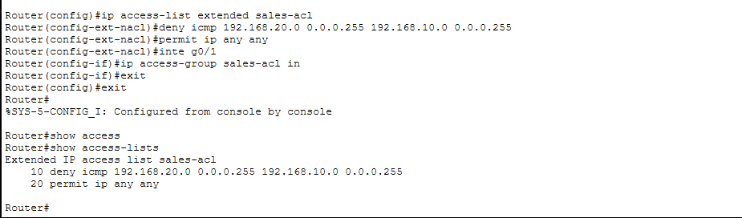

Part F:
The screenshot below confirms that despite ICMP restrictions, the Extended ACL permits Sales PCs to access the web service hosted on the IT Server ([http://192.168.10.2](http://192.168.10.2)).
